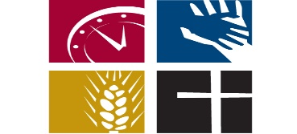
Stewardship: Transforming Our Giving
“Now the whole group of those who believed were of one heart and soul…everything they owned was held in common…and it was distributed to each as any had need.” Acts 4:32, 35

Dear Friends,
Thank you for the support you have shown Community of Faith during the past year! Your generous contributions have made a difference in our ability to do ministry to members and friends of the church, as well as reach far into our community and the world. As you recognize your place in God’s family you have realized that faithful response include use of your time, talent and financial resources as you are able, and the joy that comes from sharing in ministry in this place.
This year we have put our financial resources to use in a variety of ways. From pastoral and staff salaries, to some much needed building maintenance; to support of Nicaragua water and sewing cooperatives and local community ministries such as CLASP, Covington Partners, Be Concerned, and Transitions; to serving meals to low-income and homeless people in partnership with Union Presbyterian Church and The Cornerstone Project; to community activities such as the Ice Cream Social, Fireworks Party, Family Night, and weekly worship services, we have made effective use of the gifts we have been given and the financial resources we bring together.
This year we are focusing our energy on the Transformation 2.0 process that is designed to make us a more outwardly focused congregation that will be prepared to meet our neighbors where they are. Relationship building and developing ties to our Covington and Ludlow neighbors will be high on our priority list as we move into 2017. We will continue to worship together as a community so that we may be strengthened in the tasks that lie ahead.
We encourage you to think about how you might transform your giving this year, through making a pledge, increasing the amount you give, or sharing your talents or volunteering in a new way. As Christians we are always called to stretch ourselves, to reach out in new ways, to find out what new thing God is doing within us as individuals and as a community of faith.
Thank you again for your continued support!
Peace,
The Stewardship Committee
Miguel Carlin, Chair
Bill Lindsay
Jack Kleier
Al Jaeger
Rev. Sharon Carter, ex officio

